**MA4605 Laboratory B (Week 2) Commentary**

Students were required to complete the data sets using data entry methods, as demonstrated in class.

Students were asked to compute the mean and standard deviation of both data sets (I suggested rounding, using 4 decimal places)

|  |
| --- |
| > mean(UVSA)  [1] 84.057  > sd(UVSA)  [1] 0.3375088  >  > mean(NIRS)  [1] 83.898  > sd(NIRS)  [1] 0.3381913 |

Mean Values

* The mean of the variable UVSA is 84.057
* The mean of the variable NIRS is 83.898

Standard Deviations

* The standard deviation of the variable UVSA is 0.3375
* The standard deviation of the variable NIRS is 0.3381

|  |
| --- |
| **Interpreting p-values**   * For the sake of simplicity, the threshold value is set at 0.01 for this module. * if the p-value is less than the threshold, we reject the null hypothesis. * If the p-value is greater than the threshold, we fail to reject the null hypothesis. |

|  |
| --- |
| **Interpreting Confidence Intervals**   * The default confidence level used by ***R*** is 95% * If the null value is outside the range of the confidence limits, we reject the null hypothesis. * If the null value is within the range of the confidence limits, we fail to reject the null hypothesis. * Basing your decision on confidence intervals may result in decisions being made on the data that are different from decisions based on the previous p-value approach. |

|  |
| --- |
| > t.test(NIRS, conf.level = 0.95)  One Sample t-test  data: NIRS  t = 784.4933, df = 9, p-value < 2.2e-16  alternative hypothesis: true mean is not equal to 0  95 percent confidence interval:  83.65607 84.13993  sample estimates:  mean of x  83.898  > t.test(NIRS, conf.level = 0.99)  One Sample t-test  data: NIRS  t = 784.4933, df = 9, p-value < 2.2e-16  alternative hypothesis: true mean is not equal to 0  99 percent confidence interval:  83.55044 84.24556  sample estimates:  mean of x  83.898 |

|  |
| --- |
| **Null and Alternative Hypotheses**   * The alternative hypothesis will be stated directly in the output of many procedures. * The Null Hypothesis is the direct opposite statement of the alternative |

**Assessing the casewise differences.**

Student were required to complete the data entry using techniques and commands demonstrated, including the command data.entry().

|  |
| --- |
| UVSA = c(84.63,84.38,84.08,84.41,83.82,83.55,83.92,83.69,84.06,84.03)  NIRS = c(83.15,83.72,83.84,84.20,83.92,84.16,84.02,83.60,84.13,84.24) |

Compute the case-wise differences, i.e. the differences between measurements for each method on each case.

|  |
| --- |
| CWdiff = UVSA - NIRS  t.test(CWdiff) |

Of particular interest is the p-value and the confidence interval.

|  |
| --- |
| One Sample t-test  data: CWdiff  t = 0.8821, df = 9, p-value = 0.4007  alternative hypothesis: true mean is not equal to 0  95 percent confidence interval:  -0.2487527 0.5667527  sample estimates:  mean of x  0.159 |

The p-value is quite high. So we fail to reject the null hypothesis that the population mean of the case-wise differences in zero.

Equivalently we fail to reject the hypothesis that both methods give the same measurement, and tha there is no bias present.

The Confidence intervals can also be used to determine bias. If zero is within the range of the confidence interval then we can assume that there is no inter-method bias present.

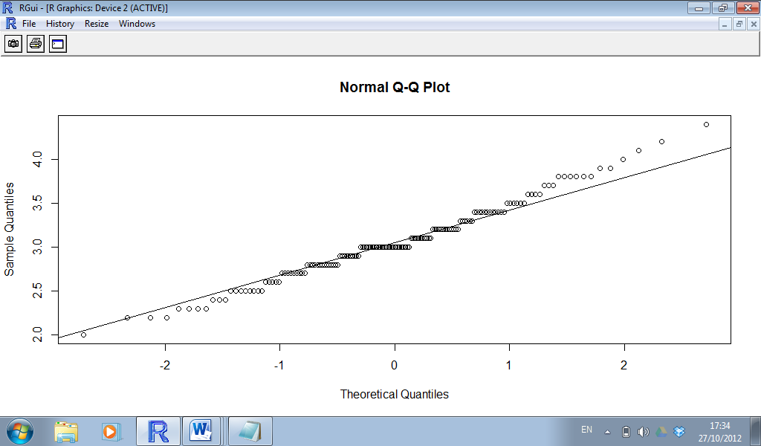

|  |
| --- |
| > shapiro.test(Sepal.Width)  Shapiro-Wilk normality test  data: Sepal.Width  W = 0.9849, p-value = 0.1011  > shapiro.test(Petal.Width)  Shapiro-Wilk normality test  data: Petal.Width  W = 0.9018, p-value = 1.68e-08  > shapiro.test(Sepal.Length)  Shapiro-Wilk normality test  data: Sepal.Length  W = 0.9761, p-value = 0.01018  > shapiro.test(Petal.Length)  Shapiro-Wilk normality test  data: Petal.Length  W = 0.8763, p-value = 7.413e-10 |

|  |
| --- |
| > qqnorm(Petal.Width )  > qqline(Petal.Width ) |

